**Git & GitHub Assignment 1 – Section 0**

**Questions:**

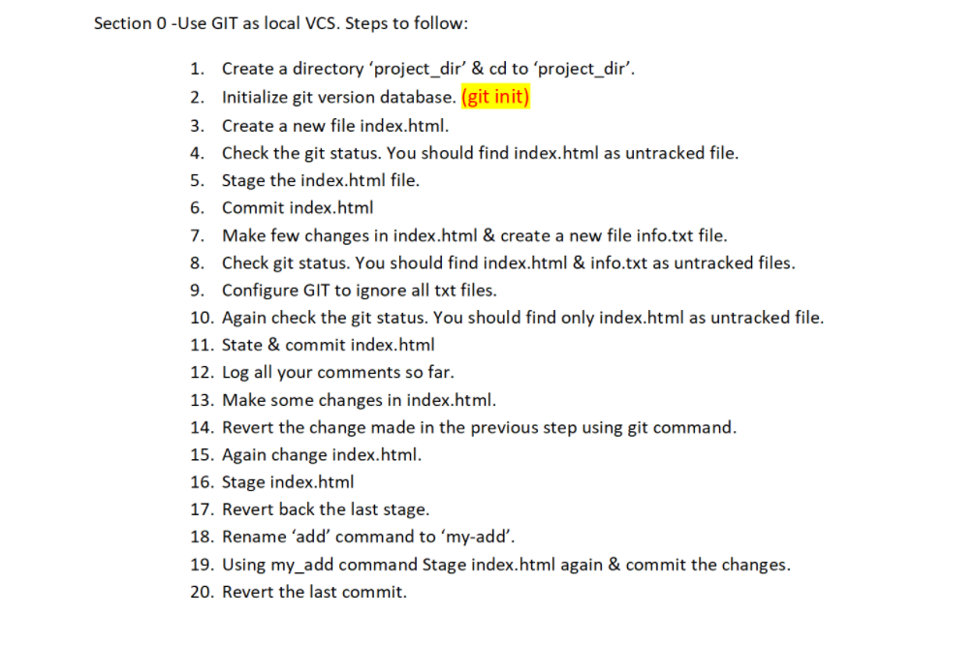

**Comments & Results:**

**$ mkdir project_dir$ cd project_dir**

**$ git init**

Initialized empty Git repository in C:/Users/jeyas/project_dir/.git/

**$ touch index.html**

**$ git status**

On branch master

No commits yet

Untracked files:

(use "git add <file>..." to include in what will be committed)

index.html

nothing added to commit but untracked files present (use "git add" to track)

**$ git add index.html**

**$ git commit -m "index.html added"**

[master (root-commit) bfa760a] index.html added

1 file changed, 0 insertions(+), 0 deletions(-)

create mode 100644 index.html

**$ git status**

On branch master

nothing to commit, working tree clean

**$ touch .gitignore**

**$ git status**

On branch master

Untracked files:

(use "git add <file>..." to include in what will be committed)

.gitignore

new.txt.txt

nothing added to commit but untracked files present (use "git add" to track)

**$ git commit -a -m"index.html added"**

On branch master

Untracked files:

(use "git add <file>..." to include in what will be committed)

.gitignore

new.txt.txt

nothing added to commit but untracked files present (use "git add" to track)

**$ git log**

commit bfa760ac242ac11272be6d18f18b502ce5f8572a (HEAD -> master)

Author: unknown <jeyasurya164@gmail.com>

Date: Mon Jul 5 13:16:21 2021 +0530

index.html added

**$ git reset --hard**

HEAD is now at bfa760a index.html added

**$ git add index.html**

**$ git restore --staged index.html**

**$ git config --global alias.my_add add**

**$ git my-add index.html**

**$ git commit -m "index.html edited"**

On branch master

Untracked files:

(use "git add <file>..." to include in what will be committed)

.gitignore

new.txt.txt

nothing added to commit but untracked files present (use "git add" to track)

**$ git reset --soft HEAD~1**